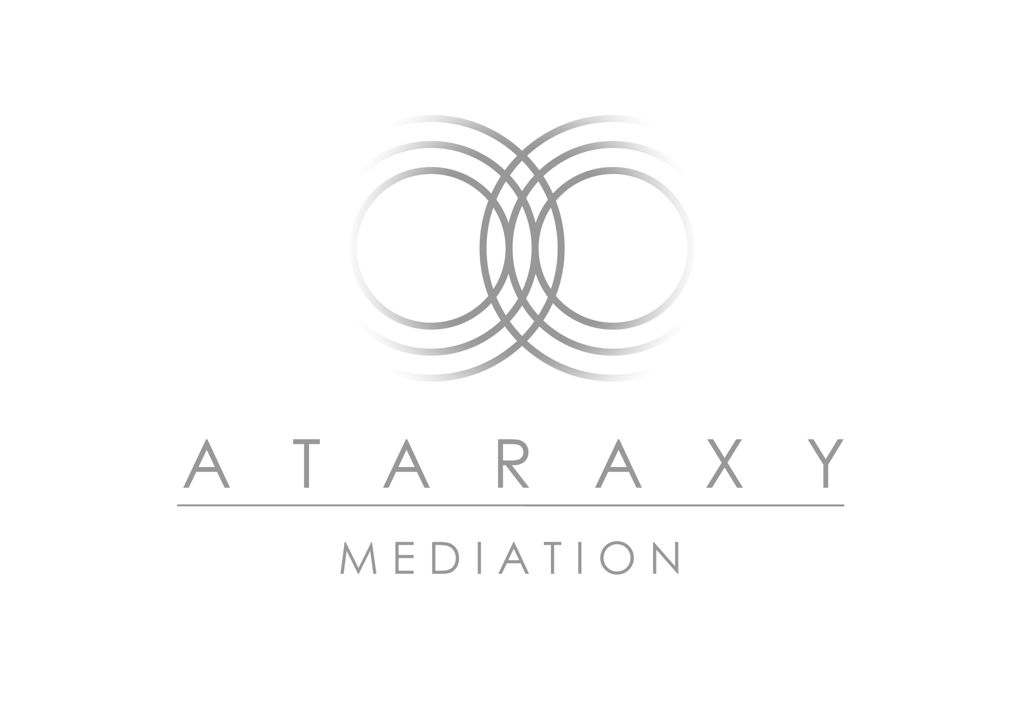
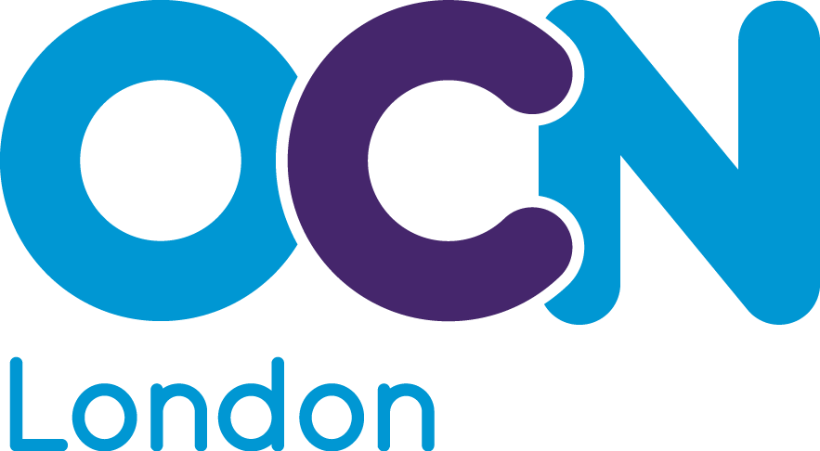
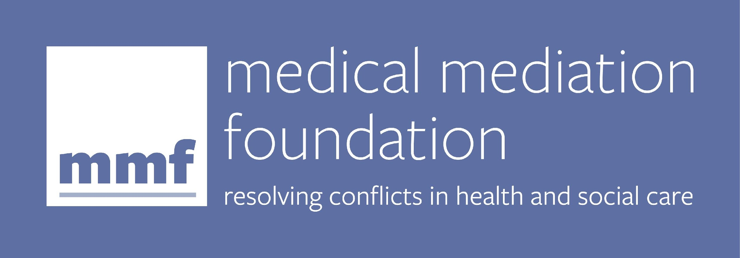

ACCREDITED PAEDIATRIC MEDICAL MEDIATION COURSE:
Training you to manage and resolve disagreements about the care and treatment of a child

The Medical Mediation Foundation in partnership with Ataraxy Mediation
Course dates 2023
Module 1: April 19, 20, 21, 24, 25, 26
Module 2: May 3, 4, 5, 8, 9
Module 3: May 16, 17, 18, 22, 23
Virtual training
Cost: £3,000
Places available: 12

Programme overview
Conflicts between health professionals, families and patients can have long-lasting impact on relationships between the family of a sick child or young person and the team providing their care and treatment. Recent, high profile court cases involving disputes over the medical treatment of babies and young children, have highlighted the need for independent mediation to be offered more frequently, to try to resolve disputes and build consensus between families and clinical teams.
Training experienced health and social care professionals and managers as accredited mediators provides them with essential skills to manage and mediate conflict between families and health professionals. This can be either within the healthcare setting where they work or as independent mediators instructed by other healthcare providers, lawyers or families.
This intensive course is taught by experts in the field of paediatrics, law, ethics, family and medical mediation. This teaching will take place over 16 x half day sessions split into three modules. It is fully accredited by the Open College Network at Level 3 (equivalent to an Advanced Diploma) and offers three units with a total of 9 credits. Endorsement by The Royal College of Paediatrics and Child Health has been applied for.
The course combines theory with coached mediation practice using a wide range of paediatric conflict scenarios. You will learn about conflict and mediation within the paediatric context, the practical skills and mindset needed to be a mediator, the process of mediation and the relevant medical law and ethics required to mediate conflict in paediatrics.
The format of the course includes pre-course reading, online interactive sessions including group discussions, practical exercises, mediation practice and reflective work. The assessment process involves an assessed filmed role play, daily reflective logs and written assignments.
Aims and learning outcomes
- To identify and understand the nature and causes of conflicts between health professionals, parents and young people in the paediatric context.
- To demonstrate a working knowledge of relevant theory, including conflict resolution frameworks, medical law and ethics, compassionate communication and relevant ethical frameworks applicable to achieving consensus between families and health professionals.
- To demonstrate a working knowledge of the key techniques and skills underpinning key aspects of medical mediation.
- To develop and demonstrate key communication and mediation skills.
- To lead and manage a mediation process, including preparation, assessment meetings, joint sessions and drafting of documentation.
- To help participants to acknowledge their personal responses to conflict and how these may affect their practice as a mediator.

Entry requirements
Those wishing to train as paediatric medical mediators must be able to work at graduate level and will usually have a degree or equivalent level of professional qualification or work experience. They will have the ability to work with conflicts and manage interpersonal relationships at a professional level, through a minimum of three years’ experience dealing with patients and families (e.g. as a doctor, nurse, allied health professional, social worker or hospital administrator). We welcome applicants from a variety of backgrounds `who can show that they have the necessary experience.

Structure of the course
The course is delivered in half day online sessions across three modules. It is essential that you attend all training sessions in order to be eligible for accreditation. With only 8-12 participants on the course, you will get to know each other well, guided by 2-3 trainers throughout. We hope you will find the course informative, stimulating and fun as well as challenging at times. Apart from presentations by the trainers, the course includes participation in group discussion, exercises, role plays and self-reflective practice.

Before the course, we will ask you to do some introductory reading. During the course we will ask you to complete a daily reflective diary. At the end of the course we will ask you to complete four written assignments (including a sample mediation agreement) as part of the assessment process.

Assessment
The course is assessed both by the trainers and by an independent assessor. The trainers will work with you during the course to help you reach the required level of competence to enable you to pass the course. If you don’t reach the required level, you will have the option to resubmit your written assignments once; and to repeat the final filmed role-play assessment (but this will incur an additional cost).

Next steps: If you reach the required standard for accreditation you will be offered the opportunity of co-mediating with one of the MMF mediators and will have your name included in the MMF register of accredited mediators.
How to apply:
Please download and complete the course application form and email it to admin@medicalmediation.org.uk

Course faculty:
Sarah Barclay, Director Medical Mediation Foundation:
Sarah is the founder of the Medical Mediation Foundation, She is an accredited mediator and also Co-Director of the Evelina Resolution Project, which provides mediation and conflict management training to clinical and non-clinical staff at the Evelina London Children’s Hospital.
In 2014 Sarah was voted an “NHS Innovator” by the Health Service Journal for her work on the Evelina project.
She has a Masters degree in Medical Law and Ethics from King’s College London and is a former award winning BBC social affairs presenter. In 2018, the Medical Mediation Foundation won Mediation Programme of the Year in the National Mediation Awards for its work on the Evelina Resolution Project.
Dr Macarena Mata
Macarena has worked professionally in the mediation and conflict resolution field since 2004. She is a qualified Trainer in mediation and conflict resolution and self-awareness to executives, academics and community groups, as well as a Trainer in peer mediation and in conflict resolution to young adults. Macarena has worked as a Lecturer at Birkbeck College, University of London, on conflict theory and reflective practice for conflict practitioners at the PgCert and MSc courses. Her company Ataraxy Mediation is registered with the Open College Network (ocnlondon.org.uk) to accredit Community Mediation, Workplace Mediation and Paediatric Medical Mediation training (in collaboration with The Medical Mediation Foundation) and is also registered with the Family Mediation Council (familymediationcouncil.org.uk) to accredit Family Mediation Foundation Courses.
Dr Claire Macaulay
Claire is an accredited mediator, trainer and executive coach. She qualified as a doctor from Liverpool University in 1999 and trained in Medical Oncology in Glasgow, picking up an MD along the way. She currently works as a Speciality Doctor in breast cancer at the Beatson West of Scotland Cancer Centre.
Claire spent 10 years as a Medico-Legal Advisor with the Medical Defence Union, supporting and defending doctors during the most difficult time in their professional lives. A passionate educator and facilitator, Claire is an accomplished, highly sought-after trainer and public speaker, specialising in advanced communication skills. Claire is the National Education Lead for Realistic Medicine, advising the Scottish Government on the educational strategy for the implementation of Realistic Medicine. She is convinced that compassionate communication can transform relationships and resolve even the most intractable disputes.
Dr Esse Menson

Esse became a consultant paediatrician in 2006 and accredited mediator in 2014. She gained a PhD in vaccine development research in 1989 before qualifying as a doctor from Bristol Medical School in 1994 then training in Melbourne, Australia and South East England to specialise in Infectious Diseases & Immunology. In 2012, she helped develop the Evelina Resolution Project with MMF while she was a consultant at the Evelina London Children’s Hospital.
Esse is one of the principal trainers working with MMF to deliver training and coaching in understanding and managing conflict to multidisciplinary health and social care professionals around the UK and internationally. She mediates conflicts in healthcare and workplace settings and is certificated in Compassion Training from the Centre for Compassion and Altruism Research and Education, Stanford, USA (2019) and Mindful Self Compassion Training (Kristen Neff/Christopher Germer model), London, UK (2019).

