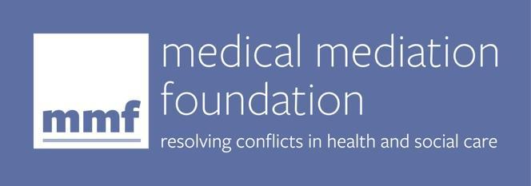

Accredited Paediatric Medical Mediation Training

Application Form

2023 course dates:
Module 1: 19, 20, 21, 24, 25, 26 April
Module 2: 3, 4, 5, 8, 9, May
Module 3: 16, 17, 18, 22, 23 May
Online
Cost: £3,000 (includes VAT)
Places available: 8-12
Thank you for applying to undertake the Accredited Paediatric Medical Mediation Training. We will review your application and get back to you within 5 working days. If you are accepted on to the course, your place will be confirmed when you have paid the £600 deposit (which includes VAT) Please do not make travel or other arrangements until we have confirmed your place.

Before we get started on obtaining your details please answer the following initial screening question:

Are you available to attend ALL the course Training Programme dates as advertised?
Yes No

If no, you would not be able to complete the accredited course and we would advise you to apply for our next training dates instead. We are happy to put you on our pre-waiting list. To do this please email admin@medicalmediation.org.uk

Personal information

Title | First name | Surname | Date of birth

Home address

Post code
Email address

Name and address for invoice if different from above. Please note, you can make an online payment once your application has been accepted. We will email you details of how to do this.

Post code
Email address

Contact details

Home tel
Mobile
Work tel
Can we contact you at work? | Yes No
Do you have any special needs that may affect your ability to learn, undertake assessed tasks/activities and/or fully participate in the programme?
Yes No

If you have answered YES, please give full details:

Please tell us why you would like to train as a paediatric medical mediator and how you hope to use the training.

Qualifications and Professional Training

Please give the following information, beginning with the most recent.

Principal Professional Qualifications relevant to this course

Educational establishment, professional or awarding body | Qualification or title of training or subject | Level/grade awarded | Year awarded or attended

Academic ability (if not educated to degree or diploma level or equivalent)

Please outline briefly (with dates) your current job/role and any previous roles where you feel you have obtained relevant work experience with conflict, managing interpersonal relationships and working with families.

I confirm I have read and agree with the Terms and Conditions relating to Paediatric Medical Mediation Training. To the best of my knowledge, the information I have given on this application is accurate, and I understand that MMF may ask for more information. I confirm that if I am accepted to join the course, I will pay a £600 (incl VAT) deposit to secure my place, and the balance by no later than 19 March 2023.
Sign:
Print:
Date:

Checklist

- I confirm I am available to attend all the advertised training dates ☐

- I confirm I have given full details of any special needs that may affect
my ability to fully participate in the programme ☐

- I have completed the registration form ☐

- I have read the Terms and Conditions ☐

